* Experiment environment

實驗時間: 2021/5/19

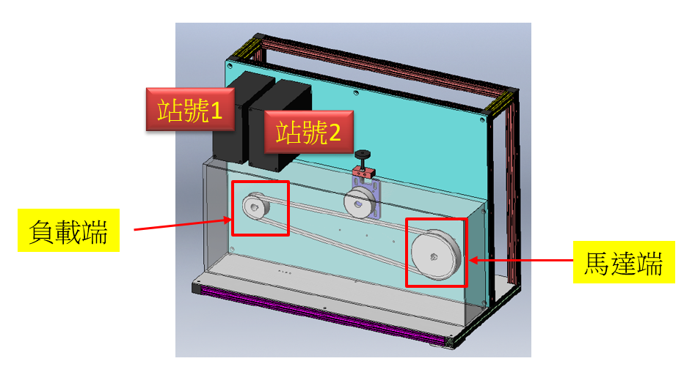

|  |  |
| --- | --- |
| 實驗時間 | 2021 / 8 / 25 |
| PLC Cycle Time | 1000ms |
| Sampling Rate | 10ms |
| 馬達端轉動頻率 | 50Hz |
| PLC Cycle Scenario | Torque=0  Delay(50ms)  Torque=100  Delay(100ms)  Torque=0  Delay(50ms) |
|  |  |
|  |  |
|  |  |

* CSV Format

|  |  |  |
| --- | --- | --- |
| Item | Description | 單位 |
| PLC Cycle | PLC cycle count |  |
| Time Stamp | TOD#Hour:Minute:Second | Time of Day format |
| Torque Command | 輸入的轉矩命令。  單位: % | XXX.X %  0.64*XXX.X NM |
| Frequency Command | 輸入的頻率命令。  50Hz | XXX.XX Hz |
| Output DC Bus | (馬達端)輸出的DC Bus | XXX.X V |
| Output Power Factor Angle | (馬達端)輸出的功因角 | XXX.X degree |
| Output Torque | (馬達端)輸出的扭力 | XXX.X %  0.64*XXX.X NM |
| Output real RPM | (馬達端)輸出的RPM | XXXXX rpm |
| Output Voltage | (馬達端)輸出的電壓 | XXX.X V |
| Output Current | (馬達端)輸出的電流 | XX.XX A |

* 軸距與量測張力

|  |  |
| --- | --- |
| 軸間  級距 | Tension  (kg) |
| 1 | 1.3 |
| 2 | 0.7 |

* Span 1/輸出電流/Cycle 150~160

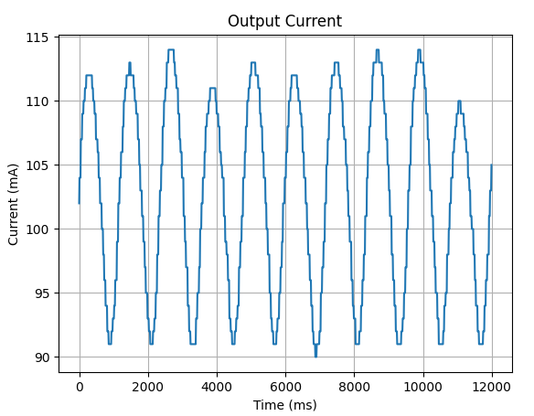

* Cycle 100

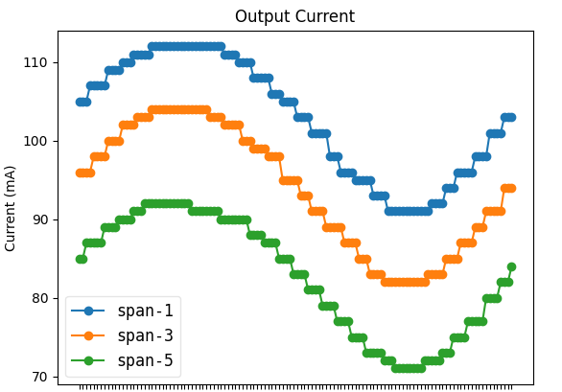

* Feature Selection

|  |  |
| --- | --- |
| Selected feature list | (('output PFA', 'mean'), 0.12244375374383212)  ~~(('output PFA', 'min'), 0.1460392763972198)~~  (('output PFA', 'max'), 0.09098568069959201)  (('output voltage', 'mean'), 0.15750936679586888)  (('output voltage', 'max'), 0.09746838786326383)  (('output current', 'min'), 0.07020864643142617) |
| Candidate feature list | (('output current', 'max'), 0.057638553506686334)  (('output voltage', 'min'), 0.052353799965962594)  (('output current', 'mean'), 0.051298046519712454)  (('output torque', 'mean'), 0.04480801493918959)  (('output torque', 'max'), 0.04393930197842289)  (('output torque', 'min'), 0.020087038203107956)  (('output DC Bus', 'mean'), 0.018059462677330024)  (('output DC Bus', 'min'), 0.013295439771717503)  (('output DC Bus', 'max'), 0.012411467291134569) |

* Tension nonlinear regression

|  |  |
| --- | --- |
| Score | Tension  (Kg) |
| 0.7284765 | 0.3 |
| 0.65 | 0.7 |
| 0.63 | 0.9 |
| 0.501 | 1.2 |